Vocabulary Review Ideas Using Sticky-Notes

PREPERATION:
*Using two different colors of post-it notes put the vocabulary word on one and the definition on another.
*place the words in a row on the whiteboard and mix up the definitions next to them.
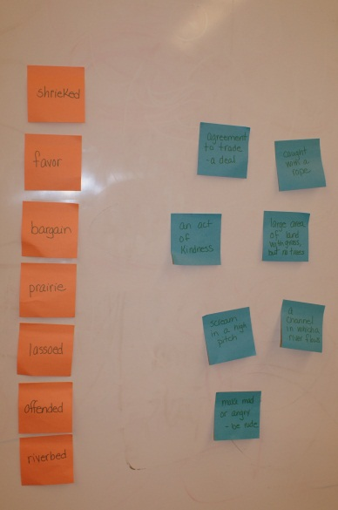
LESSON:
*First, introduce students to the words and ask them for their ideas on definitions
*Next, Use the vocabulary word in the context of a sentence to see if their definitions change at all.
*After, give them the definitions and help them to make any connections they can.
-example- recycle means to reuse or repurpose and item. Point out that “re” as a prefix means to “do again”
*Once these activities are complete have the students come up to see if they can connect the correct definition sticky note to the vocab word.
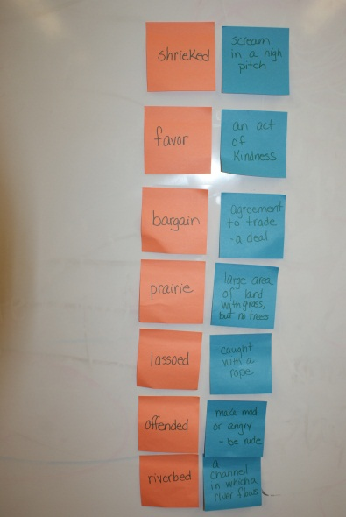
These can be matched up daily in many ways.
**put the definition and have them find the word
**put the sticky notes around the room for them to find and match up
**Individual students who need reinforcement can do them at their desk
**Put pictures of the vocabulary up and have students match the sticky-notes to them
When finished use cabinet and wall area to keep the vocabulary and definitions fresh and to refer to again.
