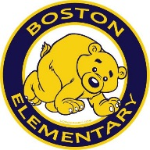
Boston Elementary Copyright and Fair Use Links

Copyright-the legal right to be the only one to reproduce, publish, and sell a book, musical recording, etc., for a certain period of time
Fair Use-a legal doctrine that portions of copyrighted materials may be used without permission of the copyright owner provided the use is fair and reasonable, does not substantially impair the value of the materials, and does not curtail the profits reasonably expected by the owner
Helpful Sites:
Copyright Basics Youtube Video
Copyright and Fair Use Slide Share
Copyright for Students
Teaching Copyright
Copyright Law for Teachers
K-12 Copyright Laws for Teachers
Fair Use for Social Media
US Copyright Office
ALA Copyright Network Links
Copyright and Fair Use-Stanford

Helpful Documents:
Copyright and Fair Use Guidelines for Teachers
Checklist for Fair Use
Copyright and Fair Use 101

